Paper Helicopter Design and Analysis

MATH 740

Nick Bealo

Kris Fargo

Erik Gustafson

Brad Olsen

October 30, 2017

# Methods

The material selected for the paper helicopter was file folder cardstock. For this size sheet, and with the intent of using the full size we picked maximum values for the nose length, rotor length, and rotor width. We then decided on minimum dimensions that would give a significant difference to the maximum and remain functional.

To significantly reduce error in the construction of the helicopters, a laser cutter was used to cut the profile dimensions specified out of the paper. To remove more variability between samples, the same paperclip was used for all of the units and a plum bob was used to mark the landing point at exactly 120 inches below the drop point. Each unit was dropped with the same technique by holding the ends of the rotors. We also instituted mock subsampling by repeating the same drop three times and taking the average of each value of drop time and radial distance from the ideal landing point. The drop time was converted to velocity in inches per second. To allow for more consistency the distance value was measured from the end of the nose of the helicopter’s original landing point to the floor marker, to remove error caused by the helicopter sliding on the ground after making contact.

For analysis, a JMP DOE generated table was filled which utilized a full factorial design. The factorial design incorporated 3 continuous factors, rotor width, rotor length, and nose length as given in the design constraints of the project. 3 center points were specified when creating the table format. The minimum and maximum bounds were entered as shown in Table 1 below.

|  |  |  |
| --- | --- | --- |
|  | **Minimum (in)** | **Maximum (in)** |
| **Rotor Length** | 3 | 6 |
| **Rotor Width** | 1.5 | 4.25 |
| **Nose Length** | 2 | 4 |

Table 1 - Dimensional Constraints

The Fit Model tool in JMP was then used to analyze the resulting effects of velocity and distance individually. The model analysis results included the actual by predicted plot to check for linearity, as well as effect summary, and effect tests. The results also showed a prediction profiler for each of the factors, which was also independently viewed in the graph profiler tool in JMP.

# Results

Observation of parameter estimates led to the conclusion that the velocity model was dominated by rotor width, based on a relatively high estimate and low p-value. Nose length was also included in the model, as while the p-value was above 5%, the estimate value was large enough to not be discounted. The accuracy model (radial distance) did not have exceptionally strong estimates for parameters, however rotor length was a strong enough factor for the model based on its estimate value. For both models, all weak factors were removed. The parameter estimates for rate of descent and accuracy are provided in Figures 1 and 2, respectively.

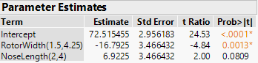

Figure 1: Parameter estimates for rate of descent (velocity measurement)

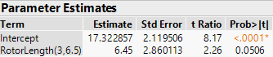

Figure 2: Parameter estimates for accuracy (distance measurement)

Through center point observation and “lack of fit” testing, the velocity model was determined to be approximately linear (small F-ratio, large p-value), while the accuracy model had some curvature (large F-ratio, small p-value). The non-linearity of the accuracy model was noted but neglected in order to continue with analysis.

With the best models determined, the prediction profiler was used to determine the optimal parameters given the initial range of inputs. The JMP Prediction Profile plots are presented in Figure 3. It is of interest to note that these values correspond to the center run values from the experiment. In addition to predictions based off interpolated profiling, values outside the range of the initial experiment were used to extrapolate other possible optimizations, while remaining within the limitations of the dimensions of a single sheet of paper. The profile for extrapolated parameters can be found in Figure 4 in the Appendix. The optimal parameters for both profiles are supplied in Table 1.

|  |  |  |  |
| --- | --- | --- | --- |
|  | **Rotor Width**  **(in)** | **Rotor Length (in)** | **Nose Length**  **(in)** |
| **Optimal**  **(Interpolated)** | 4.25 | 3 | 2 |
| **Optimal (Extrapolated)** | 5.5 | 6 | 0.5 |

Table 2: Optimal results from JMP Prediction Profiler

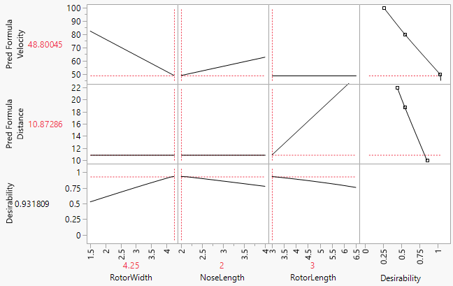

Figure 3: JMP Prediction Profile plots for original experimental ranges

Additional experimentation for the interpolated optimal parameters corresponded with previous results, and were in fact optimal in not only rate of descent, but accuracy as well. The extrapolated optimal parameters performed above average in both response categories, but did not improve upon the results from the ideal parameters chosen from the original dimension ranges.

# Conclusion

Initial helicopter dimensions were tested and optimized using JMP fit least squares methods. Upon completion of the analysis we concluded that the center run dimensions gave the best results for minimal velocity and maximum length of fall time of the tested designs. We found that the rotor width had a significant effect on the velocity model while the rotor length had a far less significant effect on the accuracy model. To further our analysis, we extrapolated the prediction profile plots to obtain the best theoretical helicopter dimensions. These proved to be only theoretical because the file paper was not rigid enough for stable flight, causing the helicopter to tumble during tests.

# Appendix

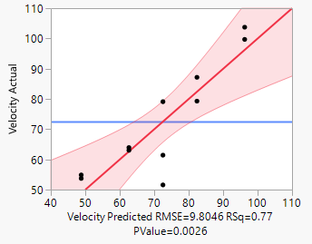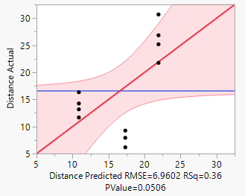

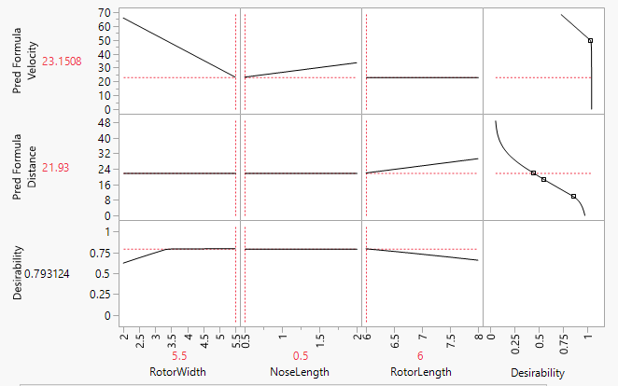

Figure 4 - JMP Prediction Profile for Extrapolated Dimensions

|  |  |  |  |  |  |  |  |  |  |  |  |
| --- | --- | --- | --- | --- | --- | --- | --- | --- | --- | --- | --- |
| **Width** | **Length** | **Nose** | **Time 1** | **Time 2** | **Time 3** | **Velocity** | $$\overline{Time}$$ | **Dist 1** | **Dist 2** | **Dist 3** | $$\overline{Dist}$$ |
| 1.5 | 3 | 2 | 1.36 | 1.42 | 1.35 | 87.17 | **1.377** | 8 | 20.5 | 20.5 | **16.33** |
| 1.5 | 6 | 4 | 0.96 | 1.42 | 1.09 | 103.75 | **1.157** | 13 | 44 | 35 | **30.67** |
| 4.25 | 3 | 4 | 1.96 | 1.79 | 1.88 | 63.94 | **1.877** | 11.5 | 14 | 9.5 | **11.67** |
| 4.25 | 6 | 2 | 2.12 | 2.01 | 2.43 | 54.88 | **2.187** | 34.25 | 33 | 13.25 | **26.83** |
| 2.875 | 4.75 | 3 | 1.49 | 1.64 | 1.42 | 79.12 | **1.517** | 2 | 10 | 6.5 | **6.17** |
| 1.5 | 3 | 4 | 1.42 | 1.16 | 1.03 | 99.72 | **1.203** | 3 | 20.25 | 19.5 | **14.25** |
| 4.25 | 6 | 4 | 2.03 | 1.88 | 1.8 | 63.05 | **1.903** | 16.5 | 28.5 | 30.5 | **25.17** |
| 4.25 | 3 | 2 | 2.18 | 2.39 | 2.13 | 53.73 | **2.233** | 19 | 9 | 11.5 | **13.17** |
| 1.5 | 6 | 2 | 1.36 | 1.49 | 1.69 | 79.30 | **1.513** | 21 | 28.75 | 15.5 | **21.75** |
| 2.875 | 4.75 | 3 | 2.35 | 2.3 | 2.33 | 51.58 | **2.327** | 5.5 | 3.25 | 15 | **7.92** |
| 2.875 | 4.75 | 3 | 2.06 | 1.9 | 1.9 | 61.43 | **1.953** | 11 | 3.5 | 13.25 | **9.25** |
| Optimized |  |  |  |  |  |  |  |  |  |  |
| 2.875 | 4.75 | 3 | 2.03 | 1.86 | 2.13 | 59.80 | **2.007** | 15.5 | 5.25 | 13 | 11.25 |
| 2.875 | 4.75 | 3 | 2.05 | 2.1 | x | 57.83 | **2.075** | 2 | 5 | x |
| 5.5 | 6 | 0.5 | 1.8 | 2.11 | 1.83 | 62.72 | **1.913** | 27.5 | 9 | 21 | 19.17 |

Table 3 -Recorded Data (all distances in inches, all times in seconds)

|  |  |  |  |  |  |  |  |
| --- | --- | --- | --- | --- | --- | --- | --- |
| **Pattern** | **Rotor Width** | **Rotor Length** | **Nose Length** | **Velocity** | **Distance** | **Pred Formula Velocity** | **Pred Formula Distance** |
| −−− | 1.5 | 3 | 2 | 87.17 | 16.33 | 82.38545455 | 10.87285714 |
| −++ | 1.5 | 6 | 4 | 103.75 | 30.67 | 96.23045455 | 21.93 |
| +−+ | 4.25 | 3 | 4 | 63.94 | 11.67 | 62.64545455 | 10.87285714 |
| ++− | 4.25 | 6 | 2 | 54.88 | 26.83 | 48.80045455 | 21.93 |
| 000 | 2.875 | 4.75 | 3 | 79.12 | 6.17 | 72.51545455 | 17.32285714 |
| −−+ | 1.5 | 3 | 4 | 99.72 | 14.25 | 96.23045455 | 10.87285714 |
| +++ | 4.25 | 6 | 4 | 63.05 | 25.17 | 62.64545455 | 21.93 |
| +−− | 4.25 | 3 | 2 | 53.73 | 13.17 | 48.80045455 | 10.87285714 |
| −+− | 1.5 | 6 | 2 | 79.3 | 21.75 | 82.38545455 | 21.93 |
| 000 | 2.875 | 4.75 | 3 | 51.58 | 7.92 | 72.51545455 | 17.32285714 |
| 000 | 2.875 | 4.75 | 3 | 61.43 | 9.25 | 72.51545455 | 17.32285714 |

Table 4 - JMP Data Table